Guide to Completing Adult Bursary Fund Application Form

This form is to request financial support with travel and materials ONLY.
For travel costs you must live in excess of 3 miles from the College, unless there are exceptional circumstances. The Materials payments is based on your course.

Eligible learners:
You must be over 19 on 31st August 2023 and enrolled on an applicable accredited course(s), not English, Maths, ESOL or IT.
To receive support from this fund, you must be in receipt of a means tested benefit or earn less than £25,000, and evidence will need to be uploaded with your application.

The Bursary is awarded if your attendance is 90% or above at any time, you can check this on e-trackr or MyDay when you are in college.

There are a number of steps to complete, please read through these notes and make sure you have everything you need before you start the application.

We ask for your Personal Details

Student Reference Number: This is your unique 8-digit number and it will have been emailed to you by the IT team and forms part of your Morley email address e.g. 01110078@morley.ac.uk. Alternatively, you can bring ID and ask reception at any centre for it. If you received an offer letter it will be on that.

Name
Date of Birth
Address
Email
Mobile Phone Number

We ask for your course details
Course Code: e.g. WXXXXXX01A, KXXXXXX02B, CXXXXXX03C, Course Title:
Campus: the site you are studying at.

We ask you to tick the days that you study

We ask for details on your financial circumstances
Please indicate monthly income amounts in the boxes provided.
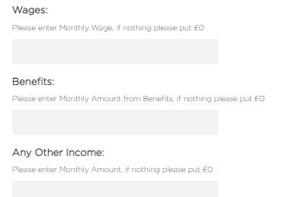

We ask the type of evidence you are going to upload
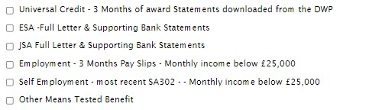

We ask you to upload the supporting evidence of the income mentioned
This can be benefit documents or pay slips. Please make sure you upload documents in full e.g. the full Universal Credit statement not just the first page. Your application will be delayed if you do not attach copies of the documents which support your claim.
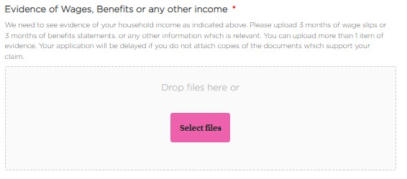

Click Select files and you can upload them
When they are uploaded they will appear in a list below the box
If you have made a mistake, click the red cross to delete and upload again

If you received an advanced learner loan for your course we ask you upload
Evidence of Advanced Learner Loan (only applicable if you have applied for a loan for your course)
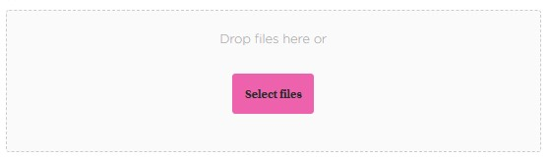
When it is uploaded, it will appear in a list below the box, if you have made a mistake, click the red cross to delete and upload again.

We ask you to complete the Bank Account Information Section
The Payments will be made once a term, the first payment being made in the week commencing 30th October 2023. Payments are made at Half Term of each term.

Payments will be made to the student by BACS transfer.
Bank Name
Account Name - This account must be in the student's name Bank Account Number Sort Code.

We ask you to agree to the declaration
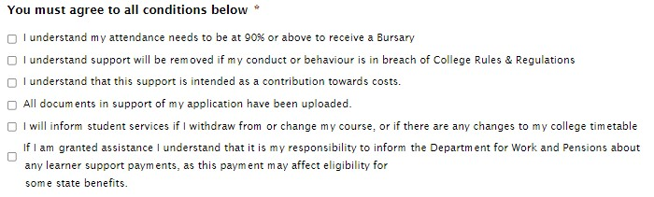

Sign and date

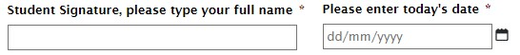

Please contact student.finance@morleycollege.ac.uk with any queries

