Guide to Completing Childcare Application for Essential Skills Students
https://www.morleycollege.ac.uk/childcare-application-for-essential-skills-students-2021-22
This form is to request help with Childcare Costs while you are studying on an Essential Skills course at Morley College. This could be English, Maths, IT or ESOL. If you are studying on a different course please email: student.finance@morleycollege.ac.uk to get the link to the correct form to complete.

There are a number of steps to complete, please read through these notes and make sure you have everything you need before you start the application.

We ask for your Personal Details
Student Reference Number: This is your unique 8 digit number and it will have been emailed to you by the IT team and forms part of your Morley email address e.g. 01110078@morley.ac.uk. Alternatively you can bring ID and ask reception at any centre for it
Name
Date of Birth
Address
Email
Phone Number

We ask for your Course Details
Course Code(s): If you are studying more than 1 course please write all codes in the box e.g. W21XXXX01A, K21XXXX02B, C21XXXX03C,
Course Title(s): If you are studying more than 1 course please write all titles in the box e.g. English Level 2, Maths Level, 1, ICT Entry Level

If you are on a course that lasts the whole year or progresses on e.g. ESOL you don’t have to reapply each term. If you join a new essential skills programme which has different hours you will need to make a new application.

Dates & Times of your course
Please confirm the days and times you attend college for classes. The college supports daytime childcare when you are timetabled to be at college or on a college related placement whether online or in person.
Please tick all that apply | When you click on a day it will drop down with start and end times for that day e.g. | If you have more than 1 course on the same day please put the start and end times together  And make sure you pick AM and PM

We ask for your Child (ren) Details
We support the cost of childcare for children aged between 1-5 years for full time care and from 5 years to 11 years for part time care, and the college can support up to 3 children per student.
Students in receipt of free childcare will be expected to use these hours to cover study time before claiming funding from the College.
You will need to provide a Birth Certificate or Passport for each child.

We ask for their name and date of birth, and below we ask you to upload the evidence

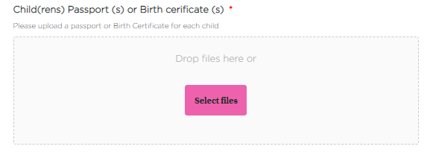
Click Select files and you can upload them

When they are uploaded they will appear in a list below the box
If you have made a mistake, click the red cross to delete and upload again.

We ask for your Childcare Provider Information
Providers must be Ofsted registered.
Payments for childcare costs will be made directly into the bank account of your childcare provider by BACS transfer every 2 weeks, no payments will be made for half terms, Christmas or Easter holidays.
Please note that it remains your responsibility to pay for any periods or amounts not approved and to pay the full cost of childcare should you stop attending regularly or withdraw from your course of study.
We will not pay any notice periods, so please make sure if you are changing childcare providers you are able to cover this cost yourself

We ask for a contact name and email address for your childcare provider and we will email them a form to complete. Once they have completed the form we let you know the details of the support.

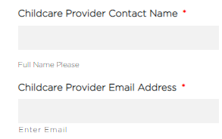

We ask for details on your financial circumstances
To receive support from this fund, you must be in receipt of a means tested benefit or earn less than £25,000. Please note, funds are limited and eligibility for the fund does not guarantee a grant will be made.
Please indicate amounts in the boxes provided.
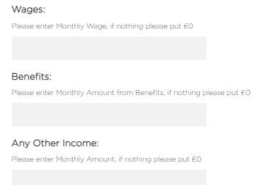,

You will need to upload 3 months of evidence of Wages, Benefits or any other income. This can be benefit documents or pay slips. Please make sure you upload documents in full e.g. the full Universal Credit statement not just the first page. Your application will be delayed if you do not attach copies of the documents which support your claim.
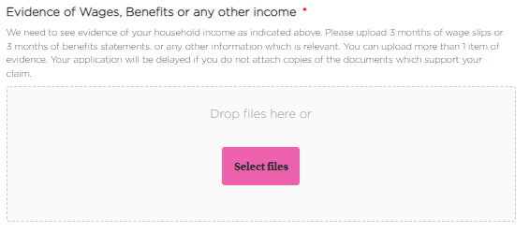
Click Select files and you can upload them

When they are uploaded they will appear in a list below the box
If you have made a mistake, click the red cross to delete and upload again.

We ask you to agree to the declaration
Read and tick all boxes and entering your full name, as a signature, and putting in the date
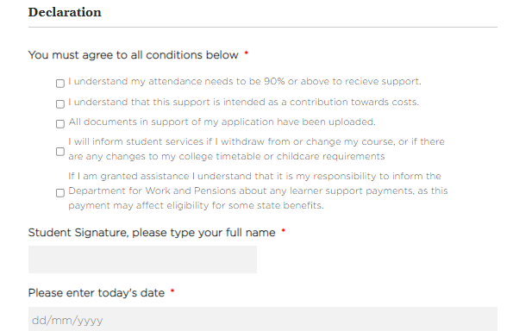
Once you click submit we will contact you childcare provider
Please contact student.finance@morleycollege.ac.uk with any queries

